Raspberry Pi Pico Gameboy

Parts List, Source, & Cost

Raspberry Pi Pico – ***Provided in American Fidelity Controller Kit***

2.2inch ILI9225 176v220 LCD Display Module - **$12.49 Amazon**

32GB Micro SD Card with adapter - **$8.99 Amazon**

Solderless Breadboard - ***Provided in American Fidelity Controller Kit***

Solderable BreadBoard - **$8.99 Amazon**

6x6x6mm Micro Push Buttons - **$4.99 Amazon**

MAX98357 I2S Audio Amplifier Module - **$6.99 Amazon**

2W 8 Ohm Small Speaker - **$8.55 Amazon**

Lithium Polymer Battery 3.7V 2000mAh - **$13.99 Amazon**

TP4056 Micro-USB Charger for Lipo Batteries - **$7.79 Amazon**

SS12F15 Miniature Slide Switch - **$4.99 Amazon**

Dupont Wires Assorted Kit (male to female & female to male) - **$14.99 Amazon**

Preformed Breadboard Jumper Wires - **$13.99 Amazon**

3D Printer Filament – ***Provided by OU Innovation Hub Fabrication Lab***

M3x4mm, M2x4mm, M6x6mm, M2x8mm head cap screws - **$29.98 Amazon**

**TOTAL COST FOR PARTS: $136.73**

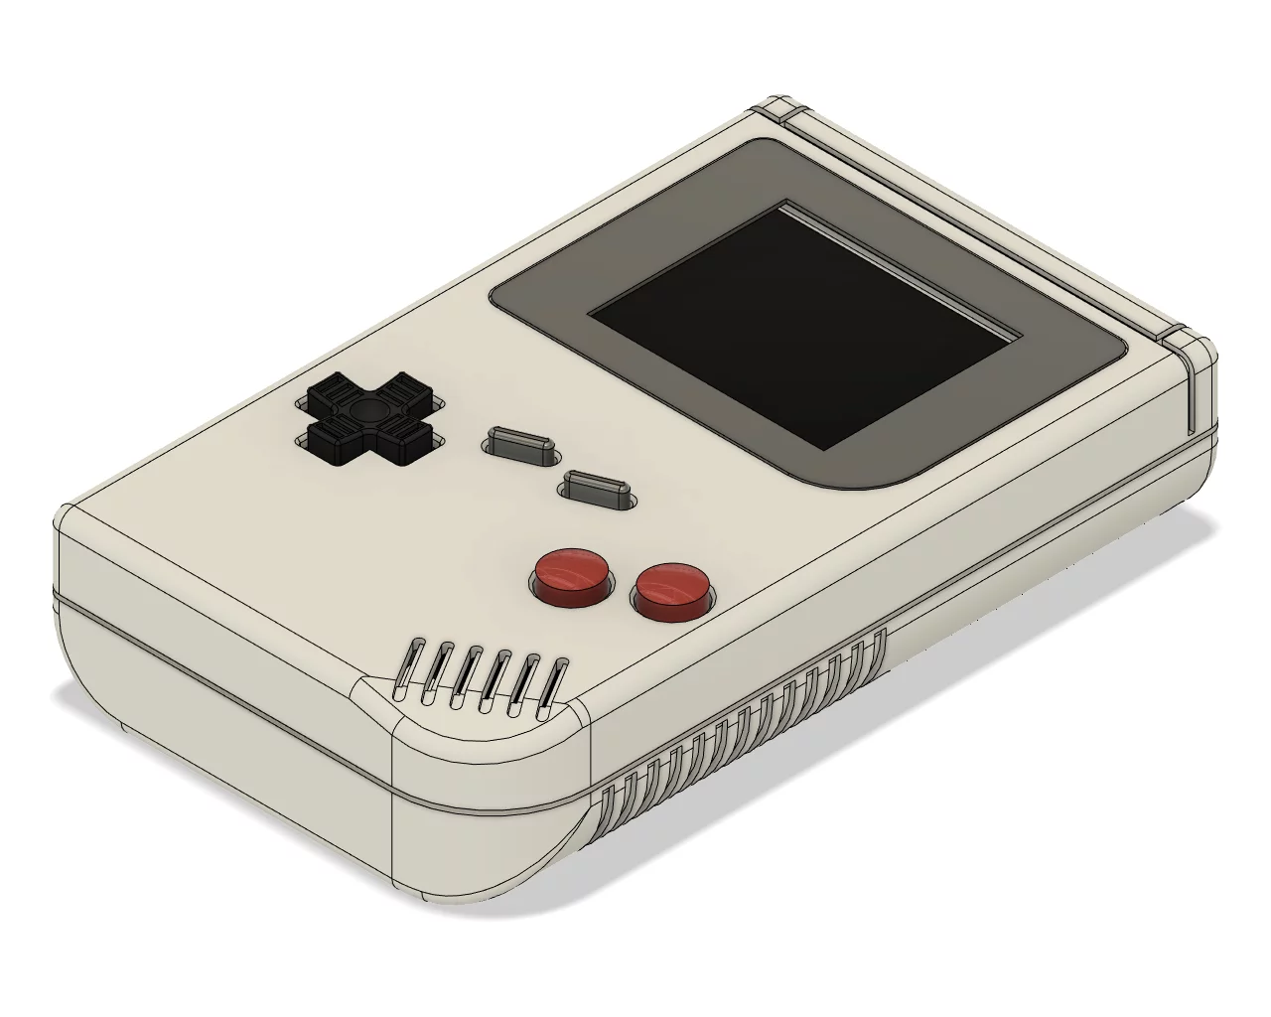

https://www.youmaketech.com/pico-gb-gameboy-emulator-handheld-for-raspberry-pi-pico/